Dothan Regional Airport restrooms for travelers including, adult, children, international people with different backgrounds.
Student Name
Institution

Contents
Introduction 3
The following are tasks that the management is done. 4
The purpose of the report 5
Scope and background of the report 6
Research methods 6
Results 8
Recommendations. 12
Conclusion 12
References 14

Dothan Regional Airport restrooms for travelers including, adult, children, international people with different backgrounds.
A recommendation report

Introduction
The report was developed to help in the process of making restrooms for people using the Dothan Regional Airport. The restrooms are well designed for adult, children and the international guest who use the airline. My task is to research in the best way that can be used a perfect restroom that will be able to satisfy the customer needs through the use of consumer and customer needs (Lipp, 2015). The restrooms will be utilized in such a manner that all the parties including children, adult, and international guests enjoy as well as the management.
My task is aimed at determining the structure where the restrooms will be constructed and determine the exact number of restrooms required in the structure. The current situation at the Dothan Regional Airport is that the guests who arrive do not benefit from well-furnished restrooms hence the need to develop restrooms that will be able to cater to their needs. The rooms available are not comfortable. They do not have an appealing taste and they do not measure to the standards of the international guests who alight from the Dothan Regional Airport (Anthony, 2014). The design to be developed should be simple and follow the set rules by the management. I have been advised to develop a remodel of the whole restroom section so that the ultimate model will resemble the model in the management head and that the design will be able to attract more visitors to use the Dothan Regional Airport.

The following are tasks that the management has done.
Determine different ways in which the restroom can be made more accessible to visitors once they land the Dothan Regional Airport. The survey involved interacting with children, elders and also the international guest who visited the Dothan Regional Airport. I collected data from various sources as well as analyzing the data by the use of secondary references to make sure that all information needed for the research is available.
The second task assigned was to determine the overall cost that will be used to run the remodeling process. The task involved the use of primary research that was to collect actual figure that has been used by other ports to remodel.
Determine the best ways that can be used to build and reconstruct more efficient restroom for all types of guest. The task required the use of secondary search that was to determine the data to be used for better restrooms. I found out that more and more restrooms will be needed as the Dothan Regional Airport grows hence remodeling the restroom was not a bad idea from the management who had seen the potential growth of the Dothan Regional Airport and hence the need to attract the customers through the remodeling of the restrooms (Lipp, 2015). The research introduction will be able to answer the following key questions, the purpose of the report, the background of the report and the scope of the report.

The purpose of the report
The main purpose of the report was to determine the best way in which restroom could be remodeled and provide better and improved services to the customers both international and local ones. The remodeling also was supposed to handle all the requirement mostly for children which was not in place when the restrooms were being constructed in the past. The remodeling was supposed to identify different ways in which the children will fully enjoy the services without complaining. The model was to be developed in such a way that the children have all they need in the restrooms (Anthony, 2014). The children rooms were to be split according to ages sot that much older children will able to ensure their privacy without being disturbed by smaller children. All forms of games were to mount in the children rooms. The design was efficient to cater for all the needs of the children who travel with their parent and desired their private rooms. On the other hand, the international rooms were to be developed in such a manner that the guest will be assigned rooms depending on where they come from.
The decision was made to ensure that guest who speaks the same language are assigned to the same roof to foster communication and sense of belonging to each guest. This was also to avoid the boredom that is the guest have nothing to share with their immediate neighbors. Visitors wishing to spend quality time in the restroom will opt for a place that they can be free and not feel biased. Additionally, an ethnic class was not considered when developing the earlier restrooms. This is a major setback and was supposed to be corrected by the new research and an immediate solution. The report was to identify various ways in which visitors with the different way of living be combined and given services as one block. This reduces time wastage and provides the visitors with irresistible services at the Dothan Regional Airport (Lipp, 2015)

Scope and background of the report
The research project was set to run at the Dothan Regional Airport. Where both the respondent and interviewees were the workers and visitors. This formed the scope of the project. In the past, the visitors had problems while using the restrooms. This problem arose from those with children and those who needed total privacy upon arriving at the port. One such issue had not been catered hence the need to develop a completely new model for the restroom with all the recommendations. Secondly, there was a need to upgrade the current restroom to a newer fashion that had been trending in the market. This was to allow for effective competition and to make sure that the Dothan Regional Airport is not left behind as compared to another Dothan Regional Airport in the USA. However, the way needs to maintain some of the factors that affected the manner in which the Dothan Regional Airport maintained its uniqueness. Such factors included, the current shape of the restrooms was to be maintained and not changed, and the theme colors were also to remain unchanged throughout the process.

Research methods
To begin the research I focused on the main purpose of restrooms and how such restrooms could be modelled to increase the number of visitors using Dothan regional Airport. The research also aimed at utilizing the restrooms to achieve the ultimate satisfaction as well as taking care of the hygiene that had deteriorated due mixed users in the restrooms. To fully understand the purpose of the restrooms at Dothan Regional Airport the following factors were considered.
What will make Dothan Regional Airport more accessible? To capture information about this, a demographic research through interaction with visitors and people surrounding the Dothan Regional Airport. This helped in determining the people we need to make the bathrooms more accessible. After the primary research was conducted I went further to conduct a secondary research which was aimed at reading more articles and books to identify how other Dothan Regional Airports have been able to conduct a successful remodeling process. The secondary research was also used to identify the common areas that children and elderly people to access the restroom. The research also enabled me to know how will be able to remodel the restrooms to fit each kid of visitors who visit the restroom. For a more successful research I hired several other researcher who were to help to bring each and every information that will be needed for a complete research. The selected were from different nationalities and background. This was to ensure that I capture each and every data needed for research and data collection. Research based on different languages was used to ensure that each participant can be able to access the research questions and answer accordingly on each section. Each researcher was expected to come up with a list of different ways on how to successfully model the restrooms in Dothan regional Dothan Regional Airport.
2. Secondly, the determination of whether the restrooms are beneficial to the customers.
To complete this part I conducted a research on how important are the restroom to employees. With this it was easy to make a conclusion that the restrooms are important to the customers. The survey also enabled me to remodel the restrooms to more accessible manner and ways in which the restrooms will be very accessible at all time. To remodel the whole process, there was a need to remove any additional materials that will be confusing to the researchers and hence making the research not successful.
3. Cost effective methods were also to be determined through the research. This was supposed to make sure that the customers will be able to access the restrooms at a more affordable price. The price was supposed to enhance a pocket friendly price that is aimed to attract the tourists to land in the Dothan Regional Airport. Several experiments were conducted to give the evaluation the best results and determine the most evident and advanced restrooms that will be used in future by the customers.

Results
Graphics signs to determine the information being presented. It was known that signs would be understood better than the verbal communication.
Hands free faucets for handicaps for them to access the restrooms. Detector lights to detect when a visitors are using the restroom.

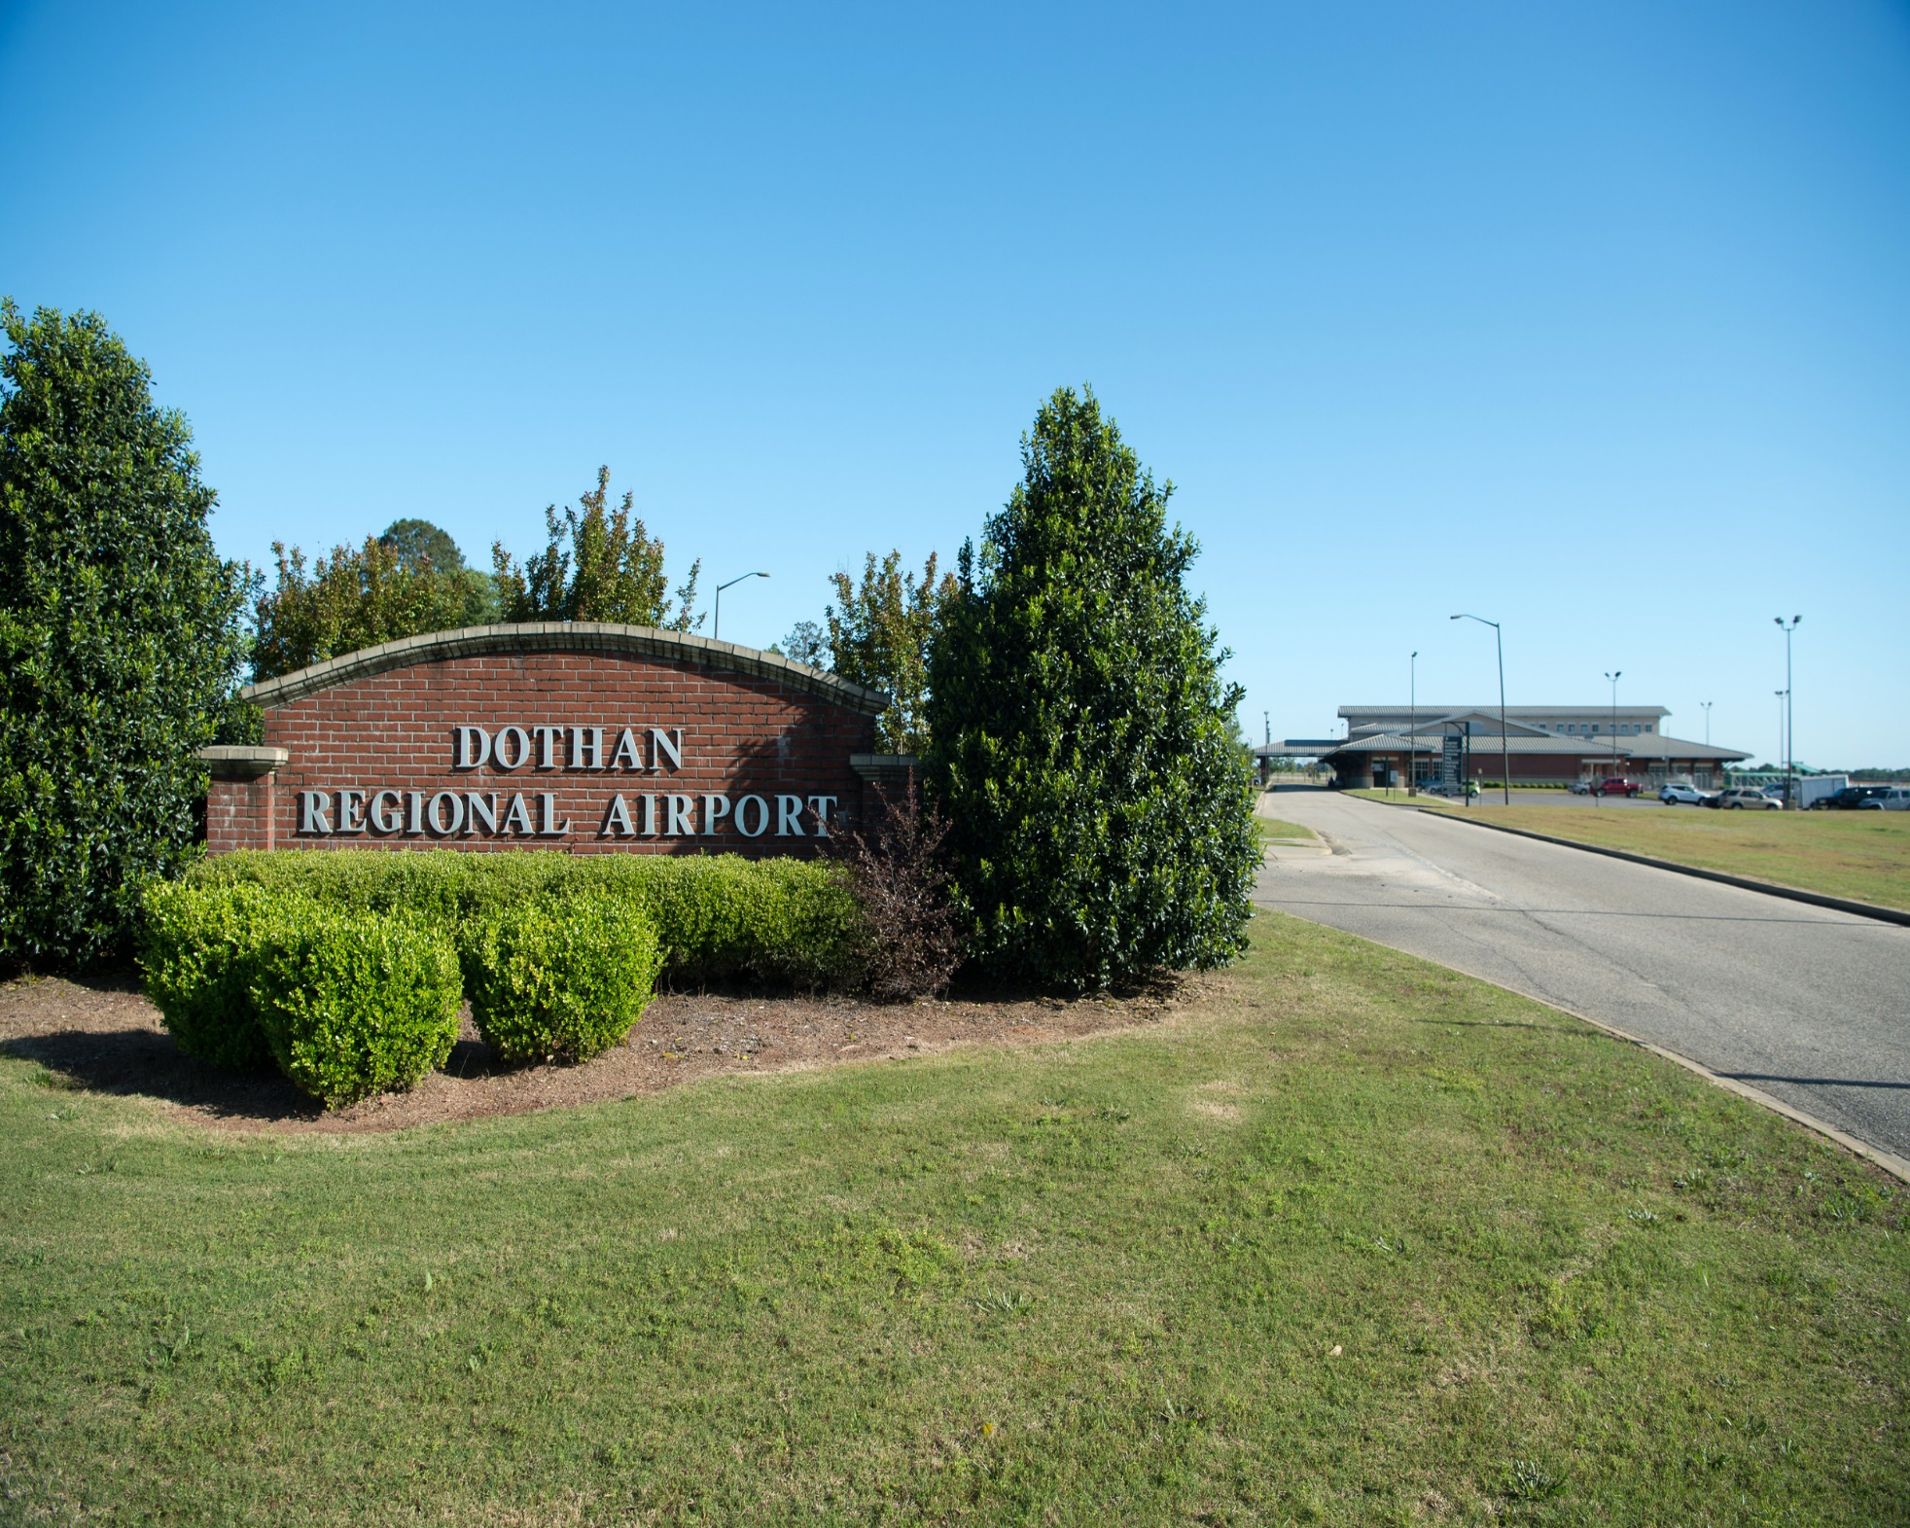

The picture above is a section of the Dothan regional Dothan Regional Airport restrooms. The restrooms are scattered and hence the need to separate and remodel the restrooms to accommodate the children, adult and international guest who use the Dothan Regional Airport.
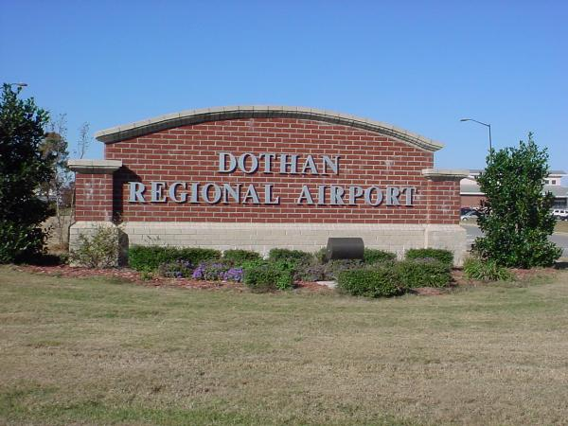
The diagram above also shows a section of the Dothan regional Dothan Regional Airport. This section is reserved for the international guest being separated from the other type users.

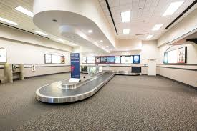
Remodeled children restroom.
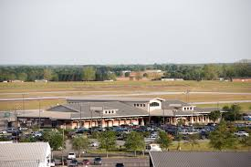
An aerial model of the adult restrooms separated from children and international guest restrooms.

Recommendations.
From the critical analysis, the following is my recommendation, the cost required for remodeling the restroom was to be considered and designed in such way that less of the resources will be channeled to the project. The management wanted a project that they will not invest a lot of money and hence forgetting other activities requiring finances. The average budget that had been estimated by Dothan Regional Dothan Regional Airport international Dothan Regional Airport restroom remodeling was $30,000. This money was to cater for all the appliances that had to be bought, the labor and other physical appliances that could be hired from other ports and later returned after the process is over. However, the direct purchase of the equipment was advantageous in a manner that the equipment will be used for lifetime services. I recommend the Dothan Regional Airport to consider purchasing of life equipment that will offer lifetime services in case of the future remodeling process.
The second recommendation was to set up the whole of the restroom section in one area of the Dothan Regional Airport. This was used to limit the upfront cost that is associated with many area investments where one thing will be repeated for a long period. This recommendation will facilitate faster collection of substantial data that will be used for positive analyzing of all the factors required in modeling. This is a positive recommendation, and the Dothan Regional Airport should consider it and implement the recommendation once the modeling process of the restrooms starts.

Conclusion
The conclusion presented is based on the tasks that were to be carried at the start of the research. Restroom should be decided to cater for all the people right from different groups, health, and wellness needs. This ensures that nobody is biased at any point while using the restroom. Secondly, increasing the number of facilities to cater for people with different needs will also be beneficial. This will ensure that guests who cannot walk are provided with wheelchairs, and their paths are made in such a way that they can be able to walk freely without any distraction. Finally, restroom designed to cater for all round guest will attract each tourist, and they will wish to use the Dothan Regional Airport route so that they can be able to access these irresistible restrooms.

References
Lipp, E. (2015). What creates access and inclusion at Dothan Regional Airports?. Journal of Dothan Regional Airport Management, 9(4), 390-397.
Anthony, K. H., & Dufresne, M. (2004). Putting potties in perspective: Gender and family issues in restroom design.
Fernandes, E., & Pacheco, R. R. (2007). Airport management: a strategic approach. Transportation, 34(1), 129-142.
Chiang, P. N. (2011). A decision support system for assessing conveyance options and modeling passenger flow in airport terminals (Doctoral dissertation, Clemson University).
Ahn, J. (2016). Development of Energy Performance Metrics for Airport Terminal Buildings using Multivariate Regression Modeling. North Carolina State University.
Liu, X., & Usher, J. M. (2016). Modeling air passengers’ rescheduling strategies for airport service lines based on an empirical study with the aid of a virtual 3-D computer graphic environment. Public Transport, 8(1), 57-84.

